**WITH NOISE AND WITH FILTER**

**Image set:**

|  |
| --- |
| **Image 1:-0.1 % Noise** |

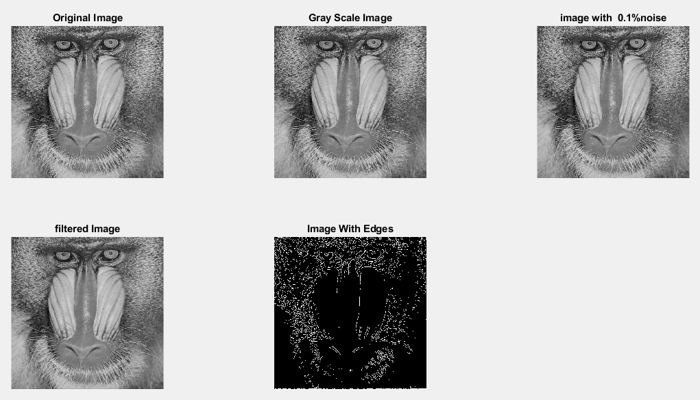

**Image 2:-10 % Noise**

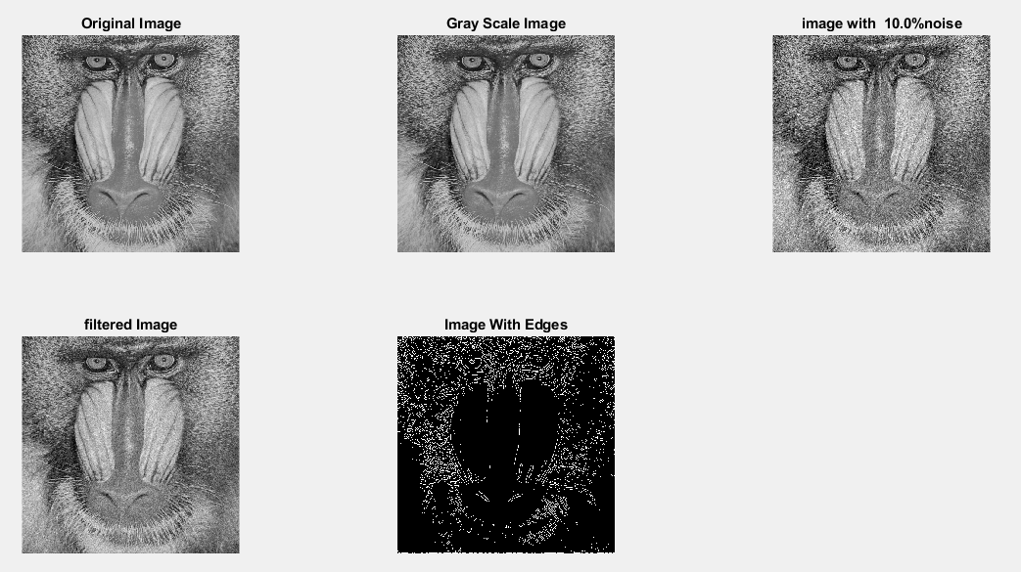

**Image 3:-20 % Noise**

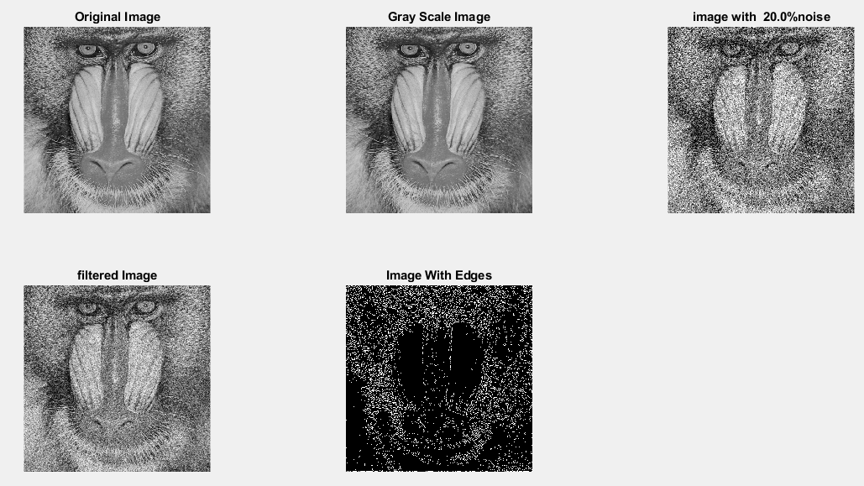

**Image 4:-30 % Noise**

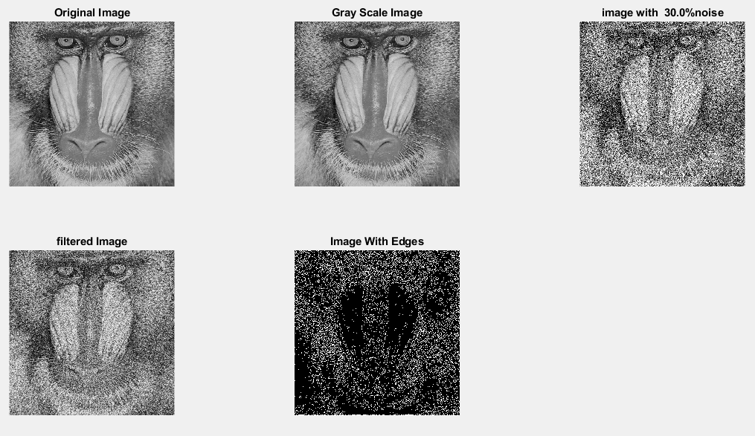

|  |
| --- |
| **Image 5:-40 % Noise** |

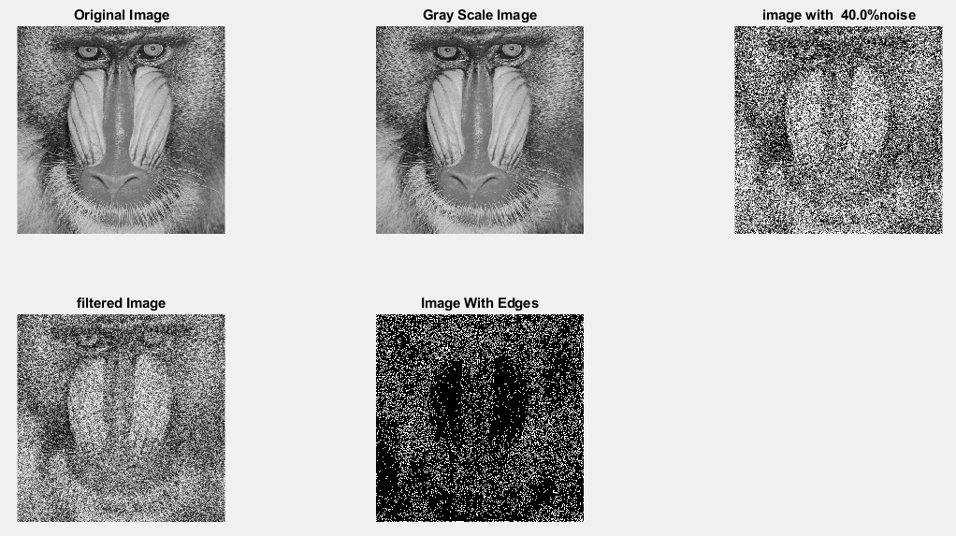

**Image 6:-50 % Noise**

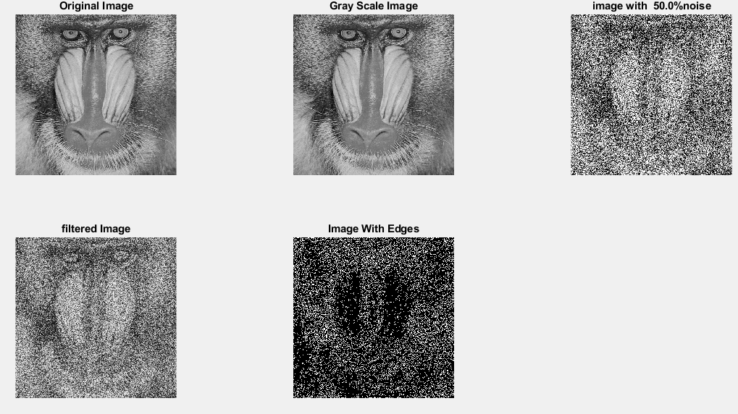

**Image 7:-60 % Noise**

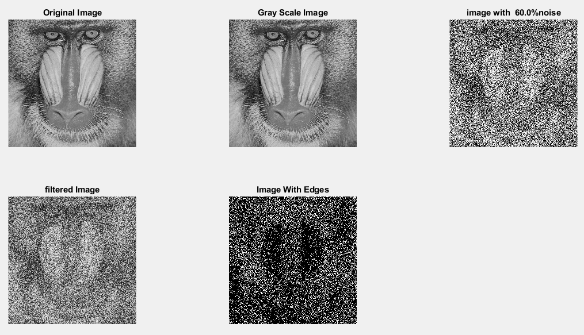

**Image 8:-70 % Noise**

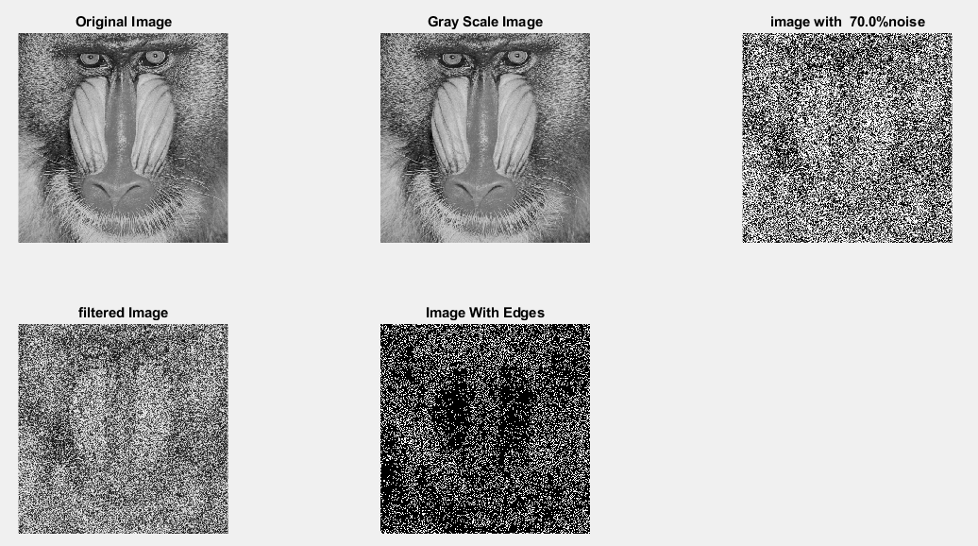

**Image 9:-80 % Noise**

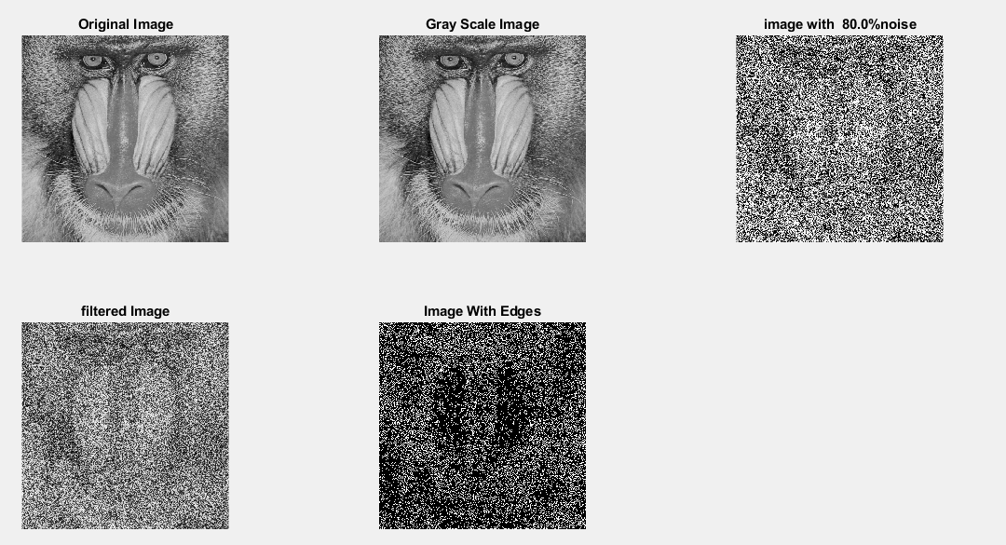

**DATA FILES**

**Image 1:-Noise0.1**

Original image ideal values:

IM1 image entropy:3.576110e-01

IM1 image mean:0.067787

Ground truth image entropy:0.943520

Ground truth image mean:0.361012

entropy between imt and im1 :0.917936

MSE between imt and im1 :0.372723

Average Difference between imt and im1 :0.293224

Maximum Difference between imt and im1 :1.000000

True Positive values:7350.000000

False Positive values: 10420.000000

True Negative values:157087.000000

False Negative values:87287.000000

Accuracy value: 0.627277

F Measure values:0.130775

Peak Signal-to Noise Ration value: 4.286142

Signal-to Noise Ration value: -7.263735

percentage of pixels that were correctly detected (Pco): 0.077665

The percentage of pixels that were not detected (Pnd):0.922335

the percentage of false alarm: (Pfa):0.110105

Euclidean Distance Value :6.892917

**Image 2:-Noise10**

Original image ideal values:

IM1 image entropy:4.104250e-01

IM1 image mean:0.082355

Ground truth image entropy:0.943520

Ground truth image mean:0.361012

entropy between imt and im1 :0.911736

MSE between imt and im1 :0.375160

Average Difference between imt and im1 :0.278656

Maximum Difference between imt and im1 :1.000000

True Positive values:8940.000000

False Positive values: 12649.000000

True Negative values:154858.000000

False Negative values:85697.000000

Accuracy value: 0.624840

F Measure values:0.153838

Peak Signal-to Noise Ration value: 4.257832

Signal-to Noise Ration value: -6.418284

percentage of pixels that were correctly detected (Pco): 0.094466

The percentage of pixels that were not detected (Pnd):0.905534

the percentage of false alarm: (Pfa):0.133658

Euclidean Distance Value :8.545145

**Image 3:-Noise20**

Original image ideal values:

IM1 image entropy:5.270507e-01

IM1 image mean:0.119198

Ground truth image entropy:0.943520

Ground truth image mean:0.361012

entropy between imt and im1 :0.896012

MSE between imt and im1 :0.383141

Average Difference between imt and im1 :0.241814

Maximum Difference between imt and im1 :1.000000

True Positive values:12723.000000

False Positive values: 18524.000000

True Negative values:148983.000000

False Negative values:81914.000000

Accuracy value: 0.616859

F Measure values:0.202138

Peak Signal-to Noise Ration value: 4.166419

Signal-to Noise Ration value: -4.812526

percentage of pixels that were correctly detected (Pco): 0.134440

The percentage of pixels that were not detected (Pnd):0.865560

the percentage of false alarm: (Pfa):0.195737

Euclidean Distance Value :12.506550

**Image 4:-Noise30**

Original image ideal values:

IM1 image entropy:6.377658e-01

IM1 image mean:0.161449

Ground truth image entropy:0.943520

Ground truth image mean:0.361012

entropy between imt and im1 :0.878837

MSE between imt and im1 :0.396446

Average Difference between imt and im1 :0.199562

Maximum Difference between imt and im1 :1.000000

True Positive values:16517.000000

False Positive values: 25806.000000

True Negative values:141701.000000

False Negative values:78120.000000

Accuracy value: 0.603554

F Measure values:0.241195

Peak Signal-to Noise Ration value: 4.018157

Signal-to Noise Ration value: -3.494845

percentage of pixels that were correctly detected (Pco): 0.174530

The percentage of pixels that were not detected (Pnd):0.825470

the percentage of false alarm: (Pfa):0.272684

Euclidean Distance Value :16.497580

**Image 5:-Noise40**

Original image ideal values:

IM1 image entropy:7.085250e-01

IM1 image mean:0.193398

Ground truth image entropy:0.943520

Ground truth image mean:0.361012

entropy between imt and im1 :0.863829

MSE between imt and im1 :0.404888

Average Difference between imt and im1 :0.167614

Maximum Difference between imt and im1 :1.000000

True Positive values:19598.000000

False Positive values: 31100.000000

True Negative values:136407.000000

False Negative values:75039.000000

Accuracy value: 0.595112

F Measure values:0.269694

Peak Signal-to Noise Ration value: 3.926649

Signal-to Noise Ration value: -2.710701

percentage of pixels that were correctly detected (Pco): 0.207086

The percentage of pixels that were not detected (Pnd):0.792914

the percentage of false alarm: (Pfa):0.328624

Euclidean Distance Value :19.744171

**Image 6:-Noise50**

Original image ideal values:

IM1 image entropy:7.477986e-01

IM1 image mean:0.213329

Ground truth image entropy:0.943520

Ground truth image mean:0.361012

entropy between imt and im1 :0.854981

MSE between imt and im1 :0.411629

Average Difference between imt and im1 :0.147682

Maximum Difference between imt and im1 :1.000000

True Positive values:21327.000000

False Positive values: 34596.000000

True Negative values:132911.000000

False Negative values:73310.000000

Accuracy value: 0.588371

F Measure values:0.283302

Peak Signal-to Noise Ration value: 3.854943

Signal-to Noise Ration value: -2.284705

percentage of pixels that were correctly detected (Pco): 0.225356

The percentage of pixels that were not detected (Pnd):0.774644

the percentage of false alarm: (Pfa):0.365565

Euclidean Distance Value :21.567487

**Image 7:-Noise60**

Original image ideal values:

IM1 image entropy:7.765180e-01

IM1 image mean:0.229145

Ground truth image entropy:0.943520

Ground truth image mean:0.361012

entropy between imt and im1 :0.847283

MSE between imt and im1 :0.416328

Average Difference between imt and im1 :0.131866

Maximum Difference between imt and im1 :1.000000

True Positive values:22784.000000

False Positive values: 37285.000000

True Negative values:130222.000000

False Negative values:71853.000000

Accuracy value: 0.583672

F Measure values:0.294546

Peak Signal-to Noise Ration value: 3.805639

Signal-to Noise Ration value: -1.974106

percentage of pixels that were correctly detected (Pco): 0.240752

The percentage of pixels that were not detected (Pnd):0.759248

the percentage of false alarm: (Pfa):0.393979

Euclidean Distance Value :23.104437

**Image 8:-Noise70**

Original image ideal values:

IM1 image entropy:7.948844e-01

IM1 image mean:0.239906

Ground truth image entropy:0.943520

Ground truth image mean:0.361012

entropy between imt and im1 :0.842792

MSE between imt and im1 :0.420750

Average Difference between imt and im1 :0.121105

Maximum Difference between imt and im1 :1.000000

True Positive values:23615.000000

False Positive values: 39275.000000

True Negative values:128232.000000

False Negative values:71022.000000

Accuracy value: 0.579250

F Measure values:0.299822

Peak Signal-to Noise Ration value: 3.759762

Signal-to Noise Ration value: -1.774794

percentage of pixels that were correctly detected (Pco): 0.249532

The percentage of pixels that were not detected (Pnd):0.750468

the percentage of false alarm: (Pfa):0.415007

Euclidean Distance Value :23.981294

**Image 9:-Noise80**

Original image ideal values:

IM1 image entropy:8.009118e-01

IM1 image mean:0.243561

Ground truth image entropy:0.943520

Ground truth image mean:0.361012

entropy between imt and im1 :0.840550

MSE between imt and im1 :0.421276

Average Difference between imt and im1 :0.117451

Maximum Difference between imt and im1 :1.000000

True Positive values:24025.000000

False Positive values: 39823.000000

True Negative values:127684.000000

False Negative values:70612.000000

Accuracy value: 0.578724

F Measure values:0.303183

Peak Signal-to Noise Ration value: 3.754332

Signal-to Noise Ration value: -1.709137

percentage of pixels that were correctly detected (Pco): 0.253865

The percentage of pixels that were not detected (Pnd):0.746135

the percentage of false alarm: (Pfa):0.420797

Euclidean Distance Value :24.413881